// Program To Create Application That Demostrate String Function in C#.

using System;

using System.Collections.Generic;

using System.ComponentModel;

using System.Data;

using System.Drawing;

using System.Linq;

using System.Text;

using System.Windows.Forms;

namespace _15.demonstrate_string_function

{

public partial class Form1 : Form

{

public Form1()

{

InitializeComponent();

}

private void button1_Click(object sender, EventArgs e)

{

string s1, s2;

s1 = textBox1.Text;

s2 = textBox2.Text;

if((s1=="")&&(s2==""))

{

MessageBox.Show("Enter Any String...", "Blank String");

}

string str = s1.Substring(0, 5);

textBox3.Text = s1.ToLower();

textBox4.Text = s1.ToUpper();

textBox5.Text = s1.Length.ToString();

textBox6.Text = str;

textBox7.Text = string.Concat(s1, "", s2);

textBox8.Text = string.Copy(s1);

textBox9.Text = s1.Trim();

textBox10.Text = s1.TrimStart();

textBox11.Text = s1.TrimEnd();

int s = string.Compare(s1, s2);

}

private void Form1_Load(object sender, EventArgs e)

{

}

}

}

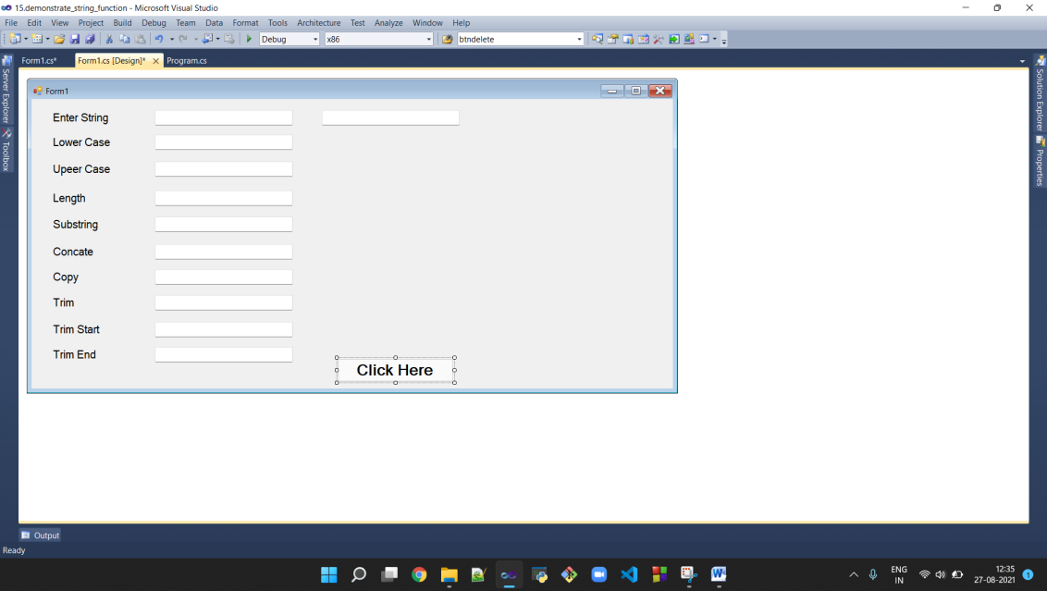

Output :-

